**TOYMANIA**

**Software Requirements Specification**

Version 1.0



**Group Id: S2002BE30D**

**Supervisor Name: Abdul Majid Khokhar**

**Revision History**

|  |  |  |  |
| --- | --- | --- | --- |
| **Date (dd/mm/yyyy)** | **Version** | **Description** | **Author** |
| 25/05/2020 | 1.0 | 1. Introduction of the project | MC190200585  SADIA HANIF |
|  |  | 1. Functional requirements 2. Use case diagram 3. Usage scenario 4. Adapted Methodology 5. Work Plan |  |
|  |  |  |  |
|  |  |  |  |

**Table of Contents**

1. Scope (of the project)
2. Functional Requirements Non Functional requirements
3. Use Case Diagram
4. Usage Scenarios
5. Adopted Methodology
6. Work Plan (Use MS Project to create Schedule/Work Plan)

**SRS DOCUMENT**

**SCOPE OF PROJECT**

This project involves building such website that provides parents and children a user friendly platform for the toy shopping. It will provide the variety of toys by taking into account the needs of children of different age groups. The primary feature of this online store will be to provide more educational toys to the children along with being entertaining so that the aspect of their personal growth can also be achieved in effective manner.

**FUNCTIONAL AND NON FUNCTIONAL REQUIREMENTS:**

**FUNCTIONAL REQUIREMENTS:**

**VISITORS**

**SING UP**:

To start shopping all users must have to sign up and registered themselves on our online store. This gives user a username and password.

**LOGIN:**

User will login to the system by entering user name and password assigned to him/her at the time of registration.

**PREVIEW PAGE:**

A preview page is available for all the toys available on our online store. This helps user to know and check the characteristics of product before buying or making any transactions.

**SEARCH BARS:**

Search bars are available on our website to search any product desired by user this will check whether the product is available in our store or not.

**USER (Buyer):**

**INFORMATION PAGE:**

An information page is available for all the toys available on our online store. This helps user to know and check the details of product before buying or making any transactions.

**SHOPPING CART:**

A shopping cart is available for all registered user to add items into it which user wants to buy.

**CANCEL ORDER:**

If user is not satisfied with the product or order and if he/she wants to cancel the order he can do this by using this feature of my online store

**FEEDBACK:**

After getting your order user have to give the feedback about product this will help administrator to make available the running items on store. It will also help user to get remarks about the product

**ADMINISTRATOR:**

**UPDATES TOYS:**

Administrator is owner of website he can update delete information of any toy available on our online store.

**MANAGES TOYS:**

Administrator is owner of website he can manage toys available on our online store.

**MANAGES CATEGORIES:**

Administrator is owner of website he can manage categories about of toys and assign the toys in particular category

**NON-FUNCTIONAL REQUIREMENTS**

**Usability:**

Usability of the software can be easy so that the user can use it easily without any difficulty

**Maintainability:**

Software should be built up in such a way that classification of errors and maintains of application becomes easy

**Operating System:**

Software should be able to run on all type of operating systems like Windows XP, Window 7 and others.

Some of the others are:

Accessibility

Security

**Actors:**

The system consists of three main modules as follows:

Admin

User

Visitors

Tools:

Application Type: Web based Application

**Tools:** PHP, MySQL, Dreamweaver, Notepad++ etc.

**Use Case Diagram:**

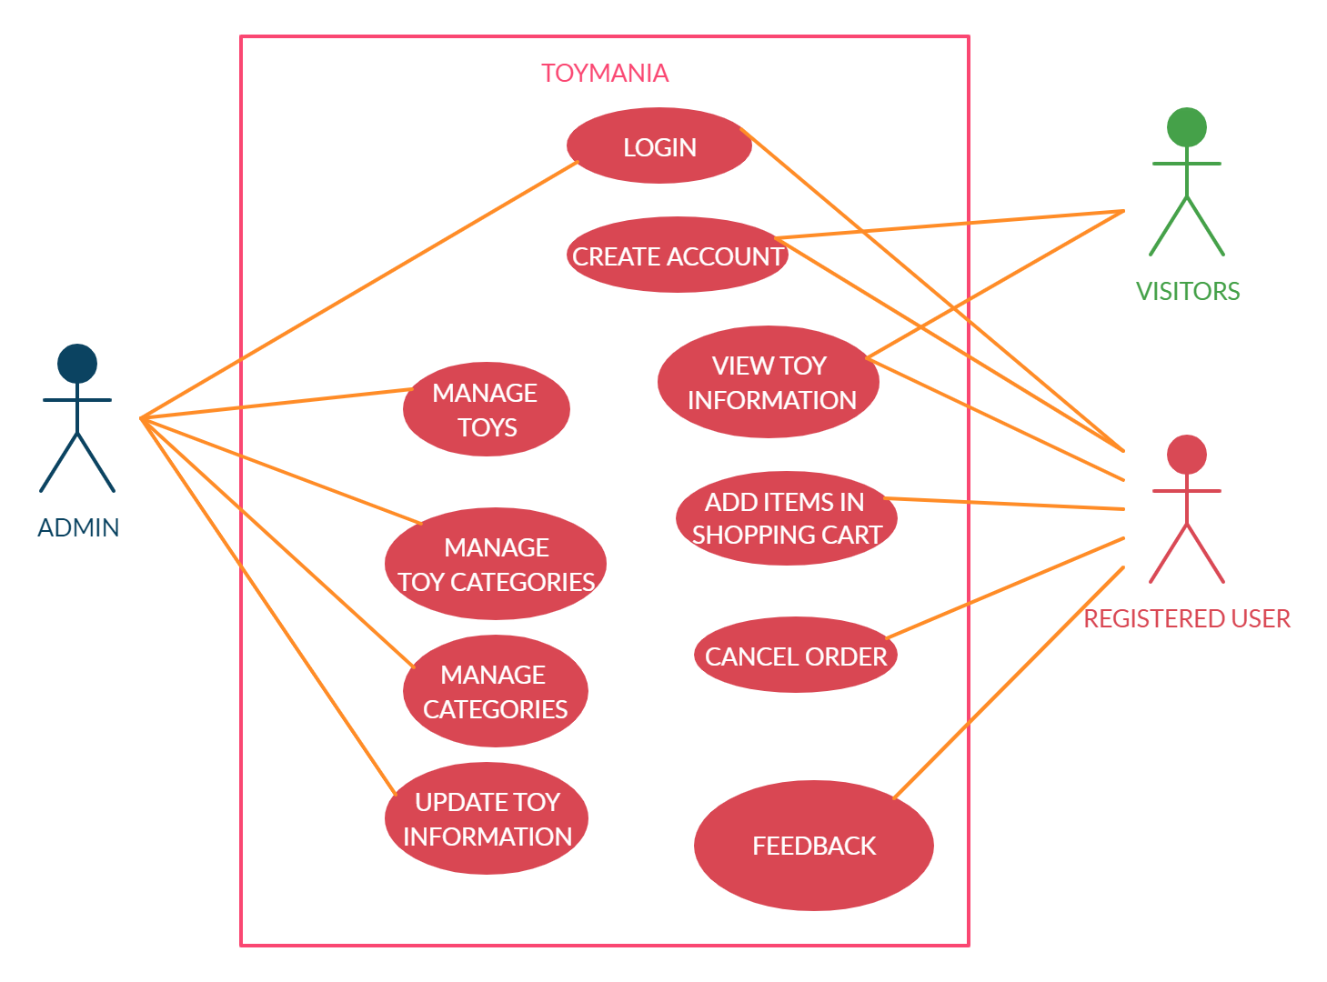

**Usage Scenarios:**

**LOGIN:**

|  |  |
| --- | --- |
| Use Case id | 1 |
| Use Case title | **LOGIN** |
| Description | All users going to login to the application. |
| Pre-condition | User must be created first, Application interface must be available |
| Action | 1. Open application interface of login 2. Enter user name and password 3. Click on “Login” button |
| Post Conditions | User successfully login and able to further work |
| Alternative Path: | User may not want to login this time |
| Exception: | If the user entered invalid data in the form then the exception occur “Invalid user name and password” |
| Authority | Admin, User |
| Author | MC190200585 (SADIA HANIF) |

**CREATE ACCOUNT**

|  |  |
| --- | --- |
| Use Case id | 2 |
| Use Case title | **CREATE ACCOUNT** |
| Description | All users who wants to buy something should have to create account. |
| Pre-condition | Application interface must be available |
| Action | 1. Open application interface of create account 2. Fill the form of registration 3. Click on “Register” button to get registered |
| Post Conditions | User successfully created now login and start ordering |
| Alternative Path: | User may not want to register this time |
| Exception: | If the user entered invalid data in the form then the exception occur “Fill mandatory Fields” |
| Authority | User, Admin |
| Author | MC190200585 (SADIA HANIF) |

**VIEW TOY INFORMATION**

|  |  |
| --- | --- |
| Use Case id | 3 |
| Use Case title | **VIEW TOY INFORMATION** |
| Description | All registered as well as non-registered users of website are able to view information about toys |
| Pre-condition | Application interface must be available |
| Action | 1. Open application interface 2. Click on view Info button |
| Post Conditions | Detailed information of product is available for user |
| Alternative Path: | User may not want to view information |
| Exception: | If user not clicked info button the information will not be displayed |
| Authority | User, Visitor |
| Author | MC190200585 (SADIA HANIF) |

**ADD ITEMS IN SHOPPING CART**

|  |  |
| --- | --- |
| Use Case id | 4 |
| Use Case title | **ADD ITEMS IN SHOPPING CART** |
| Description | A shopping cart is available for all registered user to add items into it which user wants to buy. |
| Pre-condition | Application interface must be available. User must be Logged in |
| Action | 1. Open application interface 2. Click on Shopping cart button |
| Post Conditions | Products added in shopping cart |
| Alternative Path: | User may not want to do shopping |
| Exception: | If user is not logged in this feature is not available |
| Authority | User |
| Author | MC190200585 (SADIA HANIF) |

**CANCEL ORDER**

|  |  |
| --- | --- |
| Use Case id | 5 |
| Use Case title | **CANCEL ORDER** |
| Description | If user is not satisfied with the product or order and if he/she wants to cancel the order he can do this by using this feature. |
| Pre-condition | Application interface must be available. User must be Logged in. Some items must be added in shopping cart. |
| Action | 1. Open application interface 2. Open Order page 3. Click on Request Cancel |
| Post Conditions | Your order will be cancelled |
| Alternative Path: | User may not want to do shopping |
| Exception: | If user is not logged in this feature is not available |
| Authority | User |
| Author | MC190200585 (SADIA HANIF) |

**FEEDBACK**

|  |  |
| --- | --- |
| Use Case id | 6 |
| Use Case title | **FEEDBACK** |
| Description | After getting your order user have to give the feedback about product |
| Pre-condition | Application interface must be available. User must be Logged in. |
| Action | 1. Open application interface 2. Open Product Page 3. Click on Feedback 4. Fill Feedback form and click submit |
| Post Conditions | Your feedback will be submitted |
| Alternative Path: | User may not want to do feedback |
| Exception: | If user is not logged in this feature is not available |
| Authority | User |
| Author | MC190200585 (SADIA HANIF) |

**MANAGE TOYS**

|  |  |
| --- | --- |
| Use Case id | 7 |
| Use Case title | **MANAGE TOYS** |
| Description | This use case is about adding updating or delete new different toys |
| Pre-condition | * 1. All required information about the toys should be available.   2. Database should be available in computer. |
| Action | 1. Open application interface. 2. Add all information of new toys. 3. Update information of toys 4. Delete required toys. |
| Post Conditions | New different toys are successfully added.  Toys Edit and deleted successfully and updated on website and database also |
| Alternative Path: | Admin may not want to manage toys this time. |
| Exception: | If user is not Admin in this feature is not available |
| Authority | Admin |
| Author | MC190200585 (SADIA HANIF) |

**MANAGE CATEGORIES**

|  |  |
| --- | --- |
| Use Case id | 8 |
| Use Case title | **MANAGE CATEGORIES** |
| Description | This use case is about adding updating or delete new different categories |
| Pre-condition | 1. All required information about the category should be available. 2. Database should be available in computer. |
| Action | 1. Open application interface. 2. Add all information of new category. 3. Update information of category 4. Delete required category. |
| Post Conditions | New different category are successfully added.  Category Edit and deleted successfully and updated on website and database also |
| Alternative Path: | Admin may not want to manage category this time. |
| Exception: | If user is not Admin in this feature is not available |
| Authority | Admin |
| Author | MC190200585 (SADIA HANIF) |

**UPDATE TOY INFORMATION**

|  |  |
| --- | --- |
| Use Case id | 9 |
| Use Case title | **UPDATE TOY INFORMATION** |
| Description | This use case is about updating toy information |
| Pre-condition | 1. All required information about the toy should be available. 2. Database should be available in computer. |
| Action | 1. Open application interface 2. Fill Update information of toy form |
| Post Conditions | Information updated successfully on website and also in database |
| Alternative Path: | Admin may not want to updating toy information this time. |
| Exception: | If user is not Admin in this feature is not available |
| Authority | Admin |
| Author | MC190200585 (SADIA HANIF) |

**ADOPTED METHODOLOGY**

**Definition:**

Methodology is the systematic, theoretical analysis of the methods. It’s a frame work that is used to structure, plan and control the process of developing an information system.

Vu process model which is a combination of waterfall and spiral models

**Waterfall Methodology:**

Waterfall model is the first process model to be introduced. This model is also known as linear sequential model or classic lifecycle model.

The waterfall methodology goes to the cycle of analysis ,design ,implementation ,verification, maintenance. This model is depicted in the following diagram

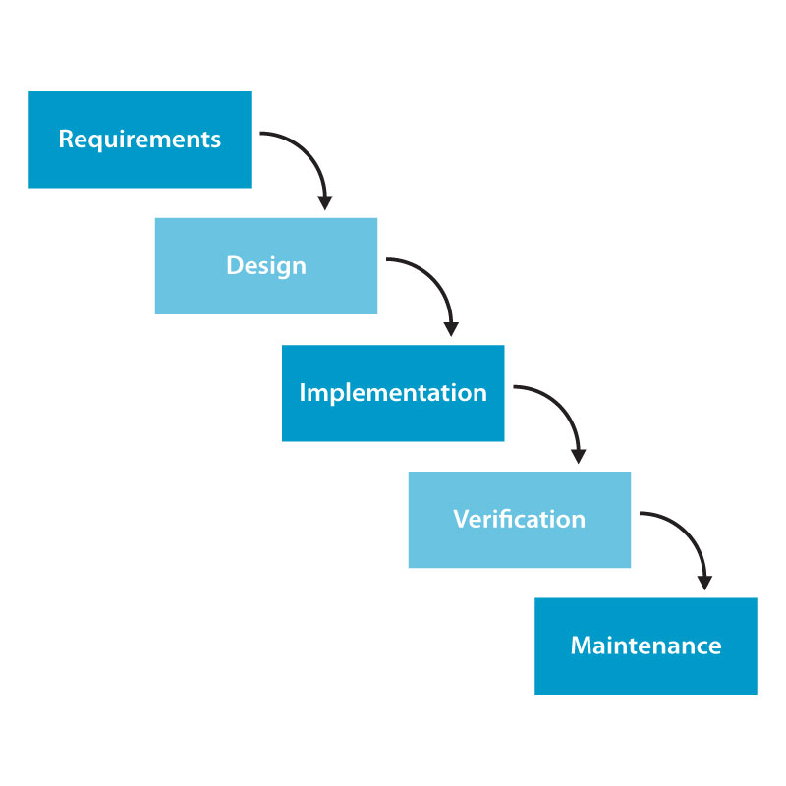

**Spiral methodology:**

The spiral model is a risk-driven software development process model. Based on the unique risk patterns of a given project, the spiral model guides a team to adopt elements of one or more process models, such as incremental, waterfall, or evolutionary prototyping

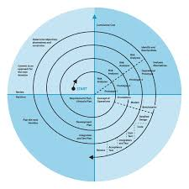

**Chosen Methodology:**

I adopt VU Process Model Method

**Reason for choosing Methodology:**

VU process model has he benefits of predictability from the mildest one based planning of the waterfall as well as the benefits of feedback and creativity from the spiral model. Some reasons are as follows:

* VU process model allows us to do correction at any stage if we want some.
* VU process model is heavily dependent on risk analysis and evaluation in each phase

**Work Plan (Use MS Project to create Schedule/Work Plan)**

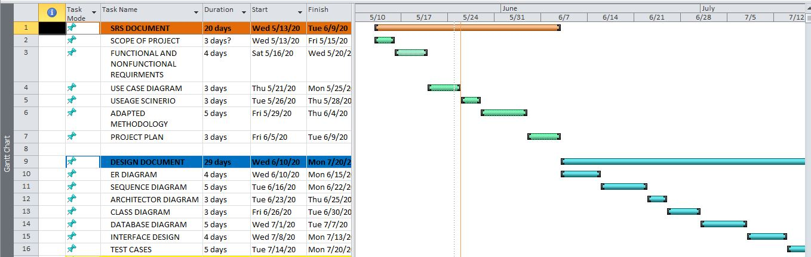**SRS DOCUMENT AND DESIGN DOCUMENT**

**TEST PHASE AND FINAL DELIVERABLES**

